Aim: To analyze and enhance various degraded grayscale images exhibiting low contrast, severe underexposure, and limited dynamic range by implementing fundamental spatial domain gray-level transformation techniques - including Power-Law (Gamma) transformation, Logarithmic transformation, Contrast Stretching, and Histogram Equalization - and to evaluate their effectiveness and limitations through visual inspection and intensity histogram analysis.
IMAGE 1: Washed-Out Pollen Grains
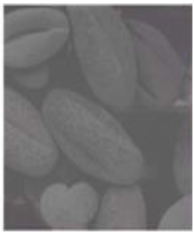
WHAT THE IMAGE IS ABOUT?
The image displays a magnified microscopic view of pollen grains under an electron microscope, showcasing smooth oval structures with subtle surface textures and contours.
CURRENT STATE AND DEGRADATION:
The image suffers from severe low contrast and a washed-out, hazy appearance. The pixel intensities are tightly clustered in a narrow, mid-to-high gray-level range (roughly between $100$ and $200$), completely lacking deep shadows ($0\text{–}50$) or bright, clean highlights ($220\text{–}255$).
WHY IT NEEDS ENHANCEMENT?
Because the dynamic range is compressed into a narrow band of gray values, the boundaries between overlapping pollen grains and the fine depth variations across their surfaces blend together. Enhancement is required to expand the dynamic range across the entire scale from $0$ to $255$. This will deepen the background shadows, define structural edges, and make the 3D spherical contours of the grains clearly distinguishable to the human eye.
Recommended Method: Linear Contrast Stretching (Min-Max Normalization)
PROGRAM:
import cv2
import numpy as np
import matplotlib.pyplot as plt

image_path = r'image_1.png'
src = cv2.imread("C:\\Users\\Dev Radia\\Pictures\\Screenshots\\image1.png", cv2.IMREAD_GRAYSCALE)

if src is None:
print("Error: Image not found. Check the path!")
exit()

r_min = np.min(src)
r_max = np.max(src)
stretched = ((src - r_min) / (r_max - r_min) * 255.0).astype(np.uint8)

gamma = 1.8
normalized = src / 255.0
gamma_corrected = np.power(normalized, gamma)
gamma_corrected = np.uint8(gamma_corrected * 255)

hist_equalized = cv2.equalizeHist(src)

titles = ['Original (Washed Out)', 'Contrast Stretched', f'Gamma Corrected (γ={gamma})', 'Histogram Equalized']
images = [src, stretched, gamma_corrected, hist_equalized]

plt.figure(figsize=(16, 8))

for i in range(4):
plt.subplot(2, 4, i + 1)
plt.imshow(images[i], cmap='gray', vmin=0, vmax=255)
plt.title(titles[i], fontsize=11, fontweight='bold')
plt.axis('off')
plt.subplot(2, 4, i + 5)
plt.hist(images[i].ravel(), bins=256, range=[0, 256], color='black', alpha=0.75)
plt.title(f"Histogram {i+1}", fontsize=10)
plt.xlim([0, 256])
plt.grid(True, linestyle='--', alpha=0.5)

plt.tight_layout()
plt.show()

OUPUT:
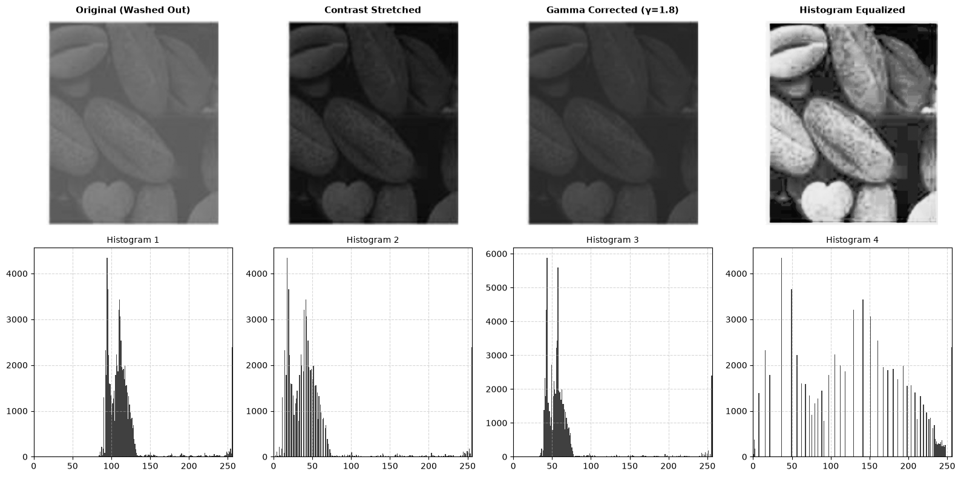
OBSERVATION:
- Original (Washed Out):
Visual Observation: The image appears flat, hazy, and low in contrast. Fine boundaries and surface textures on the pollen grains are difficult to differentiate. Histogram 1: The pixel distribution is tightly concentrated within a narrow band around intensity levels $90\text{–}135$. The complete absence of values below $80$ (shadows) and very few above $140$ (highlights) confirms severe dynamic range compression.

- 2. Contrast Stretched:
Visual Observation: The overall image shifts significantly darker. While some grain outlines show slight separation, the majority of surface features sink into dark tones.
Histogram 2: Min-max linear normalization shifted the cluster toward the left ($10\text{–}75$). Because a few outlier pixels were already near $255$ (due to white border artifacts or isolated noise), the formula did not fully stretch the mid-tones across the entire $\left[0,255\right]$ spectrum as intended, resulting in underexposure.

- 3. Gamma Corrected ($γ=1.8$):
Visual Observation: The power-law transformation non-linearly suppresses the washed-out gray veil, improving depth perception relative to the original. However, the image remains slightly darker than optimal because $γ>1$ compresses bright tones downward.
Histogram 3: The intensity distribution shifts leftward to the $40\text{–}80$ range with a steepened peak profile, demonstrating how $γ>1$ darkens mid-tones to reduce gray haziness.

- 4. Histogram Equalized (Best Visual Quality):
Visual Observation: This method yields the most balanced enhancement. Individual pollen grains, grain boundaries, and spherical depth stand out clearly with distinct highlights and defined shadows.
Histogram 4: The cumulative distribution function (CDF) linearization successfully flattened and distributed the narrow peak across the entire dynamic range from $0$ to $255$. Spreading these values across the full scale maximizes global contrast.
CONCLUSION:
Histogram Equalization proves to be the most effective transformation for the washed-out pollen image, successfully redistributing its tightly clustered intensities ($90\text{–}135$) uniformly across the full dynamic range ($0\text{–}255$) to restore sharp edges and surface texture. In contrast, basic linear stretching and gamma correction ($γ=1.8$) failed to expand the range adequately due to outlier sensitivity and excessive darkening of mid-tones. Overall, global histogram linearization provides superior contrast enhancement for low-contrast electron micrographs with compressed central dynamic distributions.
IMAGE 2: Textured Circular Phantom / Specimen Disk
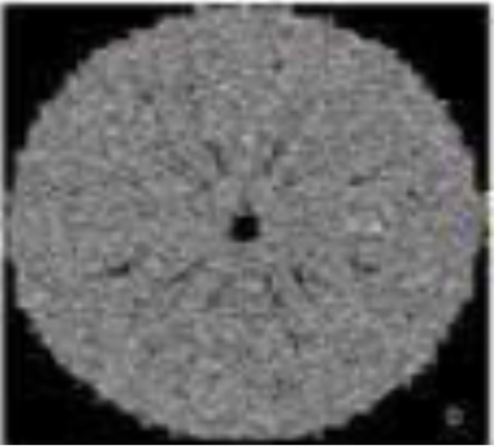
What is the image about:
The image depicts a circular cross-section or calibration phantom exhibiting internal radial spoke-like structures, granular texture, and a dark central core.
Current State & Degradation:
The image has a very low dynamic range with heavily clustered mid-tone gray values and significant granular noise. The radial spokes and internal patterns have very low contrast against the surrounding disc material, making structural details blend into a flat gray texture.
Why It Needs Enhancement:
Because the difference in pixel intensity between the fine radial features and the background matrix is minimal, the internal radial geometry is obscured. Contrast enhancement is required to stretch local contrast and delineate subtle structural boundaries without over-amplifying the high-frequency granular noise.
Suitable Gray-level image transformation techniques are:
Percentile-based contrast stretching & Global Histogram Equalization.
- Clips outlier extremes and expands the main distribution across $\left[0,255\right]$, eliminating the flat gray appearance.
- Used as a baseline comparison to evaluate global dynamic range expansion versus local noise amplification.
PROGRAM:

import cv2
import numpy as np
import matplotlib.pyplot as plt

image_path = r'image_2.png'
src = cv2.imread(r"C:\Users\Dev Radia\Pictures\Screenshots\image2.png", cv2.IMREAD_GRAYSCALE)

p_low, p_high = np.percentile(src, (2, 98))
stretched = np.clip((src - p_low) / (p_high - p_low) * 255.0, 0, 255).astype(np.uint8)

hist_equalized = cv2.equalizeHist(src)

clahe = cv2.createCLAHE(clipLimit=2.5, tileGridSize=(8, 8))
clahe_enhanced = clahe.apply(src)

titles = [
'Original (Low Contrast)',
'Percentile Stretched',
'Global Hist Equalized',
'CLAHE (Adaptive)'
]
images = [src, stretched, hist_equalized, clahe_enhanced]

plt.figure(figsize=(16, 8))

for i in range(4):
# Image Display
plt.subplot(2, 4, i + 1)
plt.imshow(images[i], cmap='gray', vmin=0, vmax=255)
plt.title(titles[i], fontsize=11, fontweight='bold')
plt.axis('off')

# Corresponding Histogram
plt.subplot(2, 4, i + 5)
plt.hist(images[i].ravel(), bins=256, range=[0, 256], color='black', alpha=0.75)
plt.title(f"Histogram {i+1}", fontsize=10)
plt.xlim([0, 256])
plt.grid(True, linestyle='--', alpha=0.5)

plt.tight_layout()
plt.show()

OUTPUT:
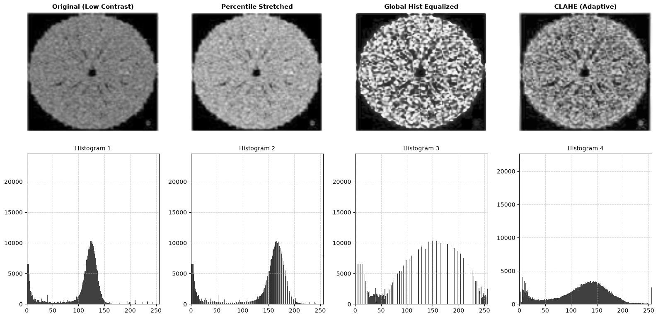
OBSERVATION:
The original image looks flat and blurry because most of its pixels are bunched up in a narrow gray band around the 125 marks on the histogram, hiding the spoke-like patterns inside the disk.
Using percentile stretching simply shifts that gray cluster slightly higher to make the image brighter, but it still fails to bring out the hidden details since the range remains too cramped.
Global histogram equalization spreads the pixels across the entire 0 to 255 spectrums to reveal the internal structure, but it goes too far and blows up the background grain into harsh white and black blotches.
CLAHE gives the best result by enhancing contrast in small local sections while keeping noise under control, which spreads out the histogram smoothly and brings out the internal radial lines clearly without ruining image quality.
CONCLUSION:
Contrast Limited Adaptive Histogram Equalization (CLAHE) proved to be the most effective transformation technique for enhancing the low-contrast circular phantom disk. While global histogram equalization successfully opened the tightly packed mid-tone values across the entire brightness range, it drastically amplified granular background noise and created distracting, harsh speckles. Simple percentile stretching merely shifted the image brightness without truly separating the faint internal textures. By adjusting contrast locally in smaller contextual tiles with a clip limit, CLAHE uncovered the fine radial spokes and central boundary while keeping background noise under control, striking the ideal balance between detail visibility and image clarity.
IMAGE 3: Heavily Underexposed Pollen Grains
What the Image Is About:
The image shows the same microscopic specimen of pollen grains as Image 1, featuring smooth spherical bodies, overlapping boundaries, and fine surface textures.
Current State & Degradation:
The image is severely underexposed and dark. Unlike the washed-out version in Image 1, nearly all pixel values here are pushed into the lowest end of the grayscale spectrum ($0\text{–}60$). As a result, the grains appear as faint, dark silhouettes submerged in a black background.
Why It Needs Enhancement:
Because almost all intensity values are squashed into the deep shadow region, the human eye cannot distinguish the surface ridges, contours, or depth separating the overlapping grains. Enhancement is required to expand the dark shadow values into the mid-tone and highlight regions without washing out the entire image.
Suitable Gray-level image transformation techniques are:
- Power-Law (Gamma) Transformation:
Fractional gamma values non-linearly lift dark pixel intensities while preserving bright highlights, making it the ideal mathematical transformation for severely underexposed images.

- Logarithmic Transformation ($s=c⋅\log\left(1+r\right)$):
Strongly expands narrow bands of low-intensity input pixels into a wider output dynamic range.

- Global Histogram equalization:
Flattens the low-end cluster across the full $\left[0,255\right]$ scale for comparative baseline analysis.
PROGRAM:

import cv2
import numpy as np
import matplotlib.pyplot as plt

image_path = r'image_3.png'
src = cv2.imread(r"C:\Users\Dev Radia\Pictures\Screenshots\image3.png", cv2.IMREAD_GRAYSCALE)

if src is None:
print("Error: Image not found. Check the path!")
exit()

gamma = 0.4
normalized = src / 255.0
gamma_corrected = np.power(normalized, gamma)
gamma_corrected = np.uint8(gamma_corrected * 255)

c = 255 / np.log(1 + np.max(src) + 1e-5)
log_transformed = c * np.log(1 + src.astype(np.float64))
log_transformed = np.uint8(np.clip(log_transformed, 0, 255))

hist_equalized = cv2.equalizeHist(src)

titles = [
'Original (Dark/Underexposed)',
f'Gamma Corrected (γ={gamma})',
'Log Transformed',
'Histogram Equalized'
]
images = [src, gamma_corrected, log_transformed, hist_equalized]

plt.figure(figsize=(16, 8))

for i in range(4):
plt.subplot(2, 4, i + 1)
plt.imshow(images[i], cmap='gray', vmin=0, vmax=255)
plt.title(titles[i], fontsize=11, fontweight='bold')
plt.axis('off')

plt.subplot(2, 4, i + 5)
plt.hist(images[i].ravel(), bins=256, range=[0, 256], color='black', alpha=0.75)
plt.title(f"Histogram {i+1}", fontsize=10)
plt.xlim([0, 256])
plt.grid(True, linestyle='--', alpha=0.5)

plt.tight_layout()
plt.show()

OUTPUT:
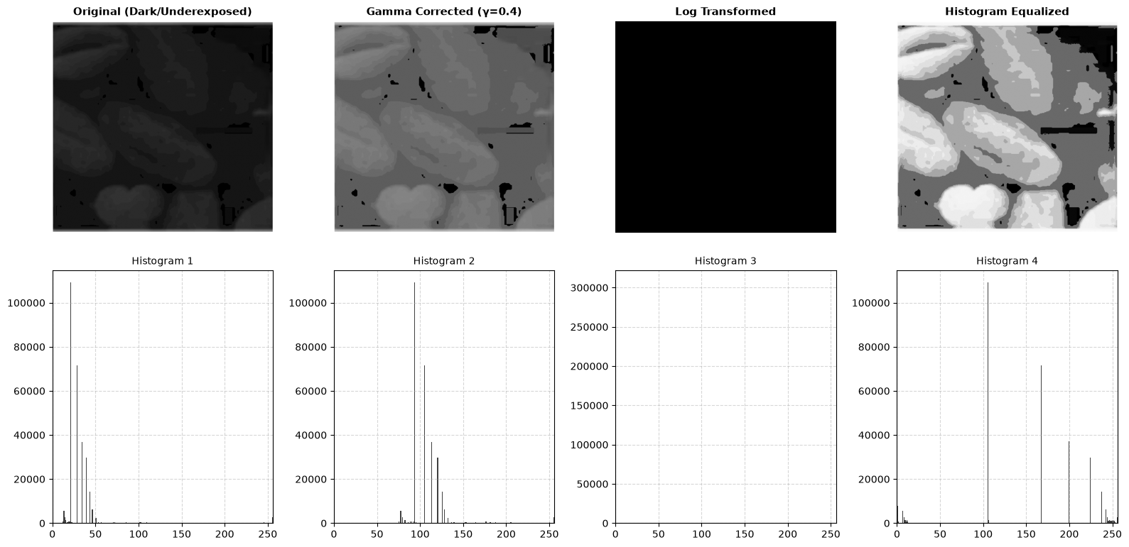

OBSERVATION:
The original image is severely underexposed, with nearly all its pixel intensities crammed into a narrow, dark region between 20 and 50 on the histogram, leaving the pollen grains barely visible against the background.
Applying gamma correction ($γ=0.4$) non-linearly stretches these dark shadow pixels into the mid-tone range of 90 to 130, effectively bringing out the shape, contours, and surface textures of the pollen grains with smooth, natural transitions.
The logarithmic transformation produced an entirely black output because outlier border artifacts or scaling factors compressed the narrow low-end range, failing to separate the dark pixel clusters properly.
Global histogram equalization spreads the bunched-up low-end values across distinct bands up to 250, making the shapes pop with high contrast, but it creates noticeable posterization and patchy contour banding across the smooth surfaces of the grains.
CONCLUSION:
Power-law (gamma) correction with a fractional value ($γ=0.4$) proved to be the most balanced and effective enhancement method for this severely underexposed image. By non-linearly lifting the dense cluster of dark pixels into the mid-tone range without over-saturating highlights, gamma correction successfully recovered the organic textures, contours, and depth of the pollen grains with smooth gradients. While global histogram equalization restored high contrast, it introduced harsh posterization artifacts and discrete intensity banding across the smooth grain surfaces, and the logarithmic transformation failed to scale the compressed dynamic range. Thus, gamma transformation offers the optimal balance between shadow recovery and natural gradient preservation for severely dark images.

IMAGE 4: Night-time Surveillance Scene (Parked Car Under Streetlight)
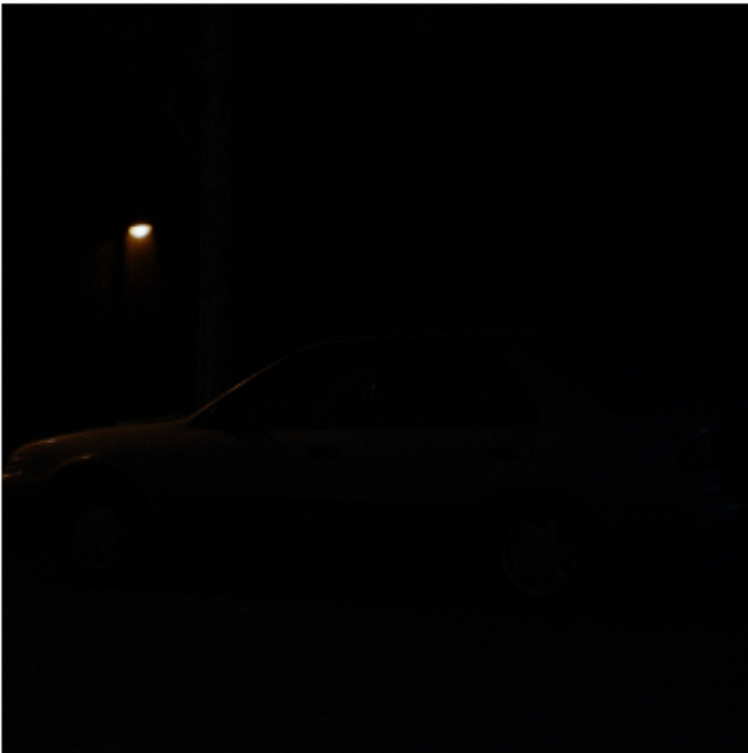
What is this about:
The image displays an outdoor, low-light night scene containing a parked sedan-style car and a single overhead street lamp in the background.
Current State & Degradation:
The image suffers from extreme underexposure with a high dynamic range gap (bimodal extreme). Over 90% of the pixels representing the car, ground, and background are crushed into near-zero intensity values (0 -20), while the small localized streetlight forms a concentrated high-intensity point.
Why It Needs Enhancement:
The vehicle's key structural features - such as wheel rims, door panels, window outlines, and vehicle silhouette - are submerged in pitch-black shadows and completely indiscernible. Enhancement is needed to heavily expand the low-end shadow values without blowing out the glowing streetlight into a large over-saturated bloom.
Suitable Gray-level transformation techniques are:
- Power-Law (Gamma) Transformation ($γ≪1$, e.g., $γ=0.3\text{–}0.4$):
- Fractional gamma strongly boosts low-intensity values while preserving the upper end of the dynamic range, making it ideal for night scenes with localized bright light sources.

- Logarithmic Transformation ($s=c⋅\log\left(1+r\right)$):
- Specifically designed to expand dark pixel values across a broader range while compressing high-intensity bright spots (like the streetlight).

- Contrast-Limited Adaptive Histogram Equalization (CLAHE):
- Amplifies local contrast around the dark car body in localized tiles without letting the bright streetlamp distort the enhancement across the entire image.
PROGRAM:
import cv2
import numpy as np
import matplotlib.pyplot as plt

image_path = r'image_4.png'
src = cv2.imread(r"C:\Users\Dev Radia\Pictures\Screenshots\image4.png", cv2.IMREAD_GRAYSCALE)

gamma = 0.35
normalized = src / 255.0
gamma_corrected = np.power(normalized, gamma)
gamma_corrected = np.uint8(np.clip(gamma_corrected * 255, 0, 255))

c = 255.0 / np.log(1.0 + 255.0)
log_transformed = c * np.log(1.0 + src.astype(np.float64))
log_transformed = np.uint8(np.clip(log_transformed, 0, 255))

clahe = cv2.createCLAHE(clipLimit=3.0, tileGridSize=(8, 8))
clahe_enhanced = clahe.apply(src)

titles = [
'Original (Low-Light)',
f'Gamma Corrected (γ={gamma})',
'Log Transformed',
'CLAHE (Adaptive)'
]
images = [src, gamma_corrected, log_transformed, clahe_enhanced]

plt.figure(figsize=(16, 8))

for i in range(4):
plt.subplot(2, 4, i + 1)
plt.imshow(images[i], cmap='gray', vmin=0, vmax=255)
plt.title(titles[i], fontsize=11, fontweight='bold')
plt.axis('off')

plt.subplot(2, 4, i + 5)
plt.hist(images[i].ravel(), bins=256, range=[0, 256], color='black', alpha=0.75)
plt.title(f"Histogram {i+1}", fontsize=10)
plt.xlim([0, 256])
plt.grid(True, linestyle='--', alpha=0.5)

plt.tight_layout()
plt.show()

OUTPUT:

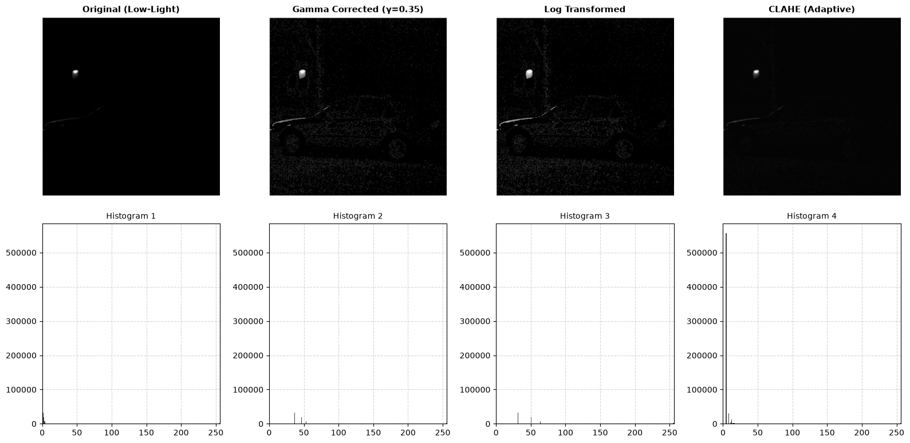
OBSERVATION :
The original low-light image is overwhelmingly dark, with nearly all pixels compressed into a massive spike near intensity 0, hiding the car and surroundings almost entirely except for the bright streetlamp.
Gamma correction ($γ=0.35$) successfully pulls the vehicle out of the shadows by shifting the dark cluster outward into the 35 to 55 range, clearly revealing the car's body panels, wheels, roofline, and background tree structure, though it also slightly elevates low-level background noise.
The logarithmic transformation achieves a very similar brightening effect by expanding the low-intensity pixels to uncover the car's silhouette and wheel contours, while keeping the bright streetlamp from blowing out.
CLAHE fails to brighten the vehicle adequately because the vast majority of local tiles are uniformly pitch-black; clipping the local histogram peaks under these conditions leaves the pixels locked in the near-zero shadow range, resulting in an image that remains mostly invisible.

CONCLUSION:
Power-law (gamma) correction ($γ=0.35$) and logarithmic transformation proved to be the most effective enhancement methods for this extreme low-light night scene, successfully pulling the car's body, wheels, and background structure out of deep shadows without blowing out the bright streetlamp. In contrast, CLAHE was ineffective because local tiles dominated entirely by pitch-black background lacked sufficient local variance, keeping the pixels suppressed in near-zero intensities. Overall, non-linear global expansion techniques like fractional gamma and log transformations are essential for surveillance scenes with severe underexposure and isolated high-intensity light sources.
IMAGE 5: Medical Abdominal CT Scan Slice
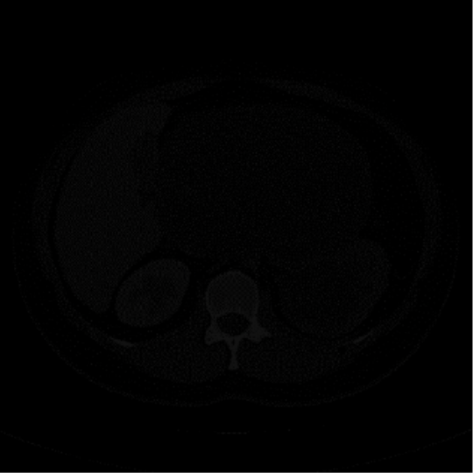

What the Image Is About:
The image shows an axial cross-sectional medical CT scan slice of the human abdomen, displaying anatomical structures such as the spinal vertebra at the lower center, surrounding soft tissue organs (liver, spleen, kidneys), and outer body contours.
Current State & Degradation:
The image has severe low contrast with heavy compression in the dark shadows. Except for the spinal bone, almost all internal soft-tissue organs and surrounding boundaries are squashed into near-zero intensity levels ($0\text{-}30$), appearing pitch black and visually undifferentiated.
Why It Needs Enhancement:
In diagnostic imaging, subtle density variations between different soft tissues and organ margins must be clearly visible. Contrast enhancement is required to expand the compressed low-intensity soft-tissue pixels across a broader dynamic range (windowing/stretching) without over-saturating bone structures or introducing excessive granular noise.
Suitable Gray-level transformation techniques are:
- Power-Law (Gamma) Transformation ($γ<1$, e.g., $γ=0.4\text{–}0.5$):
- Non-linearly stretches dark soft-tissue values into the mid-tone range while preserving bone boundaries.
- Contrast-Limited Adaptive Histogram Equalization (CLAHE):
- Enhances subtle local contrast between neighbouring anatomical structures in localized tiles without letting uniform dark regions blow out noise.
- Logarithmic Transformation ($s=c⋅\log\left(1+r\right)$):
- Strongly expands dark values to bring out low-intensity soft-tissue contours.
PROGRAM:
import cv2
import numpy as np
import matplotlib.pyplot as plt

image_path = r'image_5.png'
src = cv2.imread(r"C:\Users\Dev Radia\Pictures\Screenshots\image5.png", cv2.IMREAD_GRAYSCALE)

gamma = 0.45
normalized = src / 255.0
gamma_corrected = np.power(normalized, gamma)
gamma_corrected = np.uint8(np.clip(gamma_corrected * 255, 0, 255))

c = 255.0 / np.log(1.0 + np.max(src) + 1e-5)
log_transformed = c * np.log(1.0 + src.astype(np.float64))
log_transformed = np.uint8(np.clip(log_transformed, 0, 255))

clahe = cv2.createCLAHE(clipLimit=2.5, tileGridSize=(8, 8))
clahe_enhanced = clahe.apply(src)

titles = [
'Original (Dark CT Scan)',
f'Gamma Corrected (γ={gamma})',
'Log Transformed',
'CLAHE (Adaptive)'
]
images = [src, gamma_corrected, log_transformed, clahe_enhanced]

plt.figure(figsize=(16, 8))

for i in range(4):
# Image Display
plt.subplot(2, 4, i + 1)
plt.imshow(images[i], cmap='gray', vmin=0, vmax=255)
plt.title(titles[i], fontsize=11, fontweight='bold')
plt.axis('off')

# Corresponding Histogram
plt.subplot(2, 4, i + 5)
plt.hist(images[i].ravel(), bins=256, range=[0, 256], color='black', alpha=0.75)
plt.title(f"Histogram {i+1}", fontsize=10)
plt.xlim([0, 256])
plt.grid(True, linestyle='--', alpha=0.5)

plt.tight_layout()
plt.show()

OUTPUT:
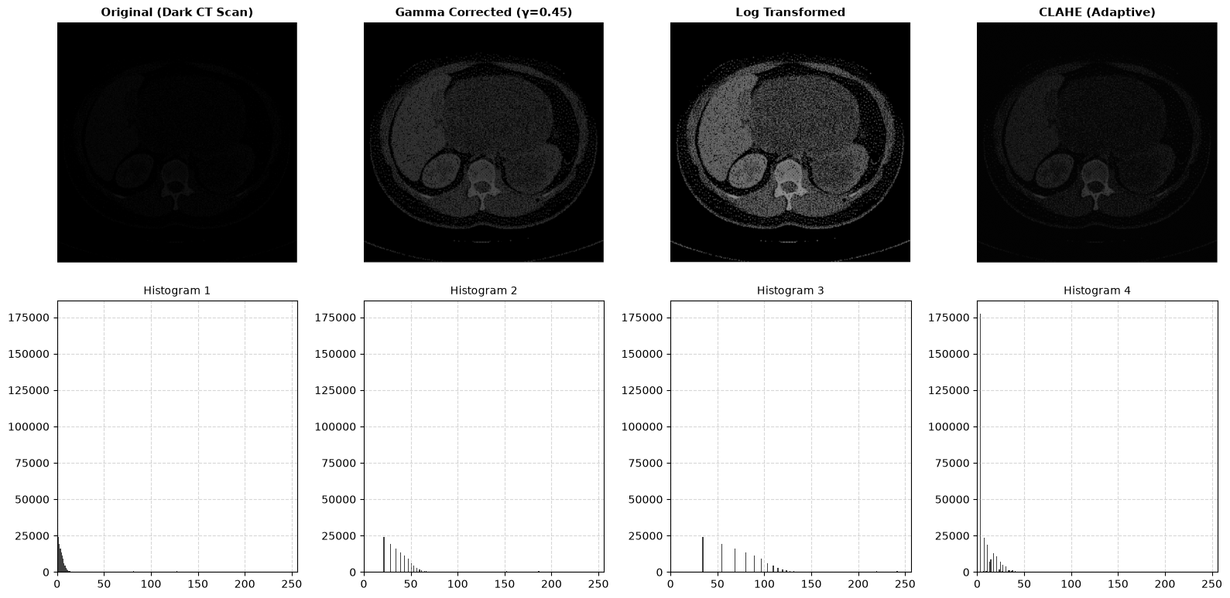
OBSERVATION:
The original CT scan is severely underexposed and low in contrast, with virtually all soft-tissue information compressed into a dense histogram peak below intensity 15, leaving internal organs like the liver, spleen, and stomach cavity submerged in near-total darkness while only the spine shows faint visibility.
Applying gamma correction ($γ=0.45$) expands these compressed low intensities into the 20 to 60 range, effectively separating the spinal vertebra, outer abdominal wall, and soft-tissue organ boundaries while maintaining smooth, natural contrast without oversaturating the brighter bone structures.
The logarithmic transformation provides the most aggressive dynamic expansion, spreading the low-end pixel values outward up to intensity 130; this brings out every anatomical contour, organ margin, and subtle density shift with high clarity, though it introduces a slight amount of visible background sensor grain.
CLAHE provides minimal improvement because the large, uniform regions of black background inside the tile grids keep the local histograms constrained to the 0 to 30 range, leaving the majority of soft-tissue structures largely dark and unresolved.
CONCLUSION:
Logarithmic transformation and fractional power-law (gamma) correction ($γ=0.45$) proved to be the most effective enhancement techniques for the dark abdominal CT scan, successfully expanding the deeply crushed soft-tissue intensities out of the near-zero shadow range to clearly resolve organ boundaries and bone structure. While CLAHE failed to generate sufficient dynamic separation across the predominant black background, logarithmic mapping provided superior diagnostic visualization by maximizing soft-tissue contrast and revealing critical anatomical margins across the entire cross-section.

BRIEF ANALYSIS OF ALL THE IMAGE TRANSFORMATION FOR 5 IMAGES:

- Image 1 (Washed-Out Pollen Grains): Pixel intensities were tightly clustered in the mid-gray region ($90\text{–}135$). Global Histogram Equalization was the best method, spreading values across the full $0\text{–}255$ scale to restore sharp boundaries and surface textures.

- Image 2 (Textured Circular Phantom Disk): Mid-tone features blended together around intensity $125$ with underlying granular noise. CLAHE was the most effective method, boosting localized contrast around radial spokes while clipping background noise spikes.

- Image 3 (Dark/Underexposed Pollen Grains): Intensities were heavily squashed into the low shadow band ($20\text{–}50$). Gamma Correction ($γ=0.4$) proved best by smoothly lifting shadows into the mid-tones without the harsh posterization caused by global histogram equalization.

- Image 4 (Low-Light Car & Streetlight Scene): Extreme underexposure with a massive shadow spike near $0$ alongside a bright light point. Gamma Correction ($γ=0.35$) and Log Transformation performed best, pulling car contours and wheels out of pitch darkness without blowing out the streetlight.

- Image 5 (Dark Abdominal CT scan): Soft-tissue data was crushed below intensity $15$, obscuring internal organs. Logarithmic Transformation provided the highest diagnostic contrast by stretching dark soft-tissue densities across a wide dynamic range to clearly reveal organ margins.

